This document provides an overview of the types of pay codes used in WFM/Time Management and the options to consider when configuring pay codes.
Updated with Portal screens and settings
Nov 22

Contents
1. Background 1
2. Time & Pay Codes 1
3. Pay Code Types 2
4. Creating/amending Pay Codes 3
Example 1 – Adding a new absence type 4
Example 2 – Adding a new Casual Pay Code 5
Example 3 – Adding an Employee Request (balance-linked) code 6

Background
All time (hours & minutes) needs to be recorded against a valid Pay Code. Pay Codes originate in CorePay, but require specific configuration within Core Time to function properly with Timesheets and/or Leave/Absence.

For full guidance on configuring pay codes for WFM refer to the Pay Codes guide

Time & Pay Codes

WFM Admin Dashboard > Settings > Reference Data > Pay Codes

Pay codes only need to be activated in Time Management if they are required for leave & absence or timesheets.

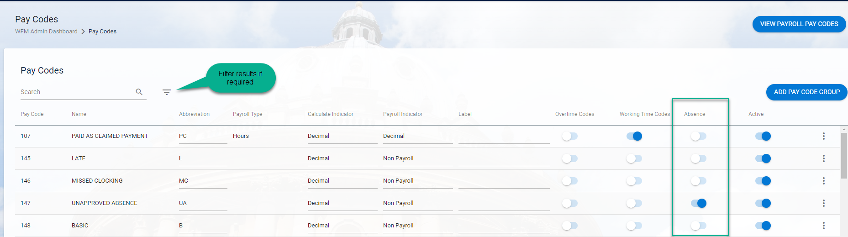

There are 14 screens of parameters for each pay code. Rather than attempting to detail all of these options, pay codes can be grouped based on their behaviour.

Pay Code Types
Pay codes can be broken into two categories:-

- Leave & Absence – codes which record time away from work
- Timesheets – codes which record hours worked and result in payment to workers

Within these two categories there are several sub-categories:

Category | Subcategory | Notes | Example(s)
Leave & Absence  Non-pay affecting | Employee Request  (balance-linked) | Codes which an employee can request triggering a workflow to the manager, and when approved, deduct from a pre-assigned balance (e.g. the annual leave balance) | Annual Leave
 | Employee Request | Codes which an employee can request triggering a workflow to the manager | TOIL
 | Absence - Basic | Codes that can be recorded against an employee’s appointment and block out the time in the team scheduler | Study Leave (Unpaid)
 | Absence - Advanced | Codes that can be recorded against an employee’s appointment and block out the time in the team scheduler, but also drive a workflow (e.g. return to employee sickness self-certification) | Sickness Absence
Timesheets  Pay affecting | Paid as Claimed Work | Codes that can be recorded on a timesheet claim and will be transferred to Payroll, while also accruing a % of the hours to the respective accrual holiday balance | Clerical Asst - Proj (H)
 | Paid As Claimed Holiday | Codes that can be recorded on a timesheet claim and will be transferred to Payroll, deducting hours from the respective accrual holiday balance | Hol Pay - GL (H)
 | Employee Work | Codes that can be recorded on a timesheet claim but do not impact an accrual balance | Overtime x 2

Creating/amending Pay Codes
A series of questions need to be considered when setting up or amending pay codes in Time. Settings can then be copied from existing pay codes before reviewing the test environment.

Create a reason code(s) and add these to a reason code group, or select an existing reason code group and link to the pay code - WFM Admin Dashboard > Settings > Configuration Settings > Pay Code Groups

Sensitive absences should not have ‘Display on Co-Worker Roster’ ticked on ‘Leave Request Settings’.
See subcategories
Add to the relevant Working Time Group columns
CoreTime/Core Roster > System Params > Reference Q-Z > Working Time Parameters > Working Time Group 029 > Pay Code Groups button
Add the code to the relevant Pay Code Groups so that employees and managers can record time against it - WFM Admin Dashboard > Settings > Configuration Settings > Pay Code Groups

Example 1 – Adding a new absence type
This is an example only, illustrating how to determine which pay code settings to mirror based on the intended code behaviour.
A new University policy introduces a Green Day, where employees can take 1 day off per annum to focus on activities which have a positive impact on the environment.

The benefit is only available to employees with set hours of work, it is added to the Employee Support Staff and Employee Academic-related Pay Code Groupings.
No reason is required for this absence, it doesn’t need to be linked to a reason group
The absence isn’t considered sensitive and can be displayed to colleagues on the Co-Worker’s roster’
The code will be recorded by the employee’s manager or HR department, as per the subcategory ‘Absence – Basic’
The code involves taking time off and is therefore a ‘Leave & Absence code’
The code can be added to the ‘Emp Absence’ column, as it isn’t relevant for Sign off.

Example 2 – Adding a new Casual Pay Code
This is an example only, illustrating how to determine which pay code settings to mirror based on the intended code behaviour.
A new casual pay code has been set up Casual Catering Assistant (HRS).

The code can be added to the ‘Emp Absence’ column, as it isn’t relevant for Sign off.
A new Pay Code Grouping would need to be created, Casual Catering Assistant – GL, containing the code and the CAS HOLIDAY PAY (HRS)
The absence isn’t considered sensitive and can be displayed to colleagues on the Co-Worker’s roster’
Hours worked against this code cause the casual worker to accrue holiday pay, it therefore falls into the category of Paid as Claimed Work, updating the casual holiday accrual balance
This is an hourly payment code for casual work, it is pay affecting and is therefore a Timesheet code.
No reason is required for this code, it doesn’t need to be linked to a reason group

Example 3 – Adding an Employee Request (balance-linked) code
This is an example only, illustrating how to determine which pay code settings to mirror based on the intended code behaviour.
A new absence code is required for research staff to record their development days

Employees will have up to 10 days per year to use of development activities, which they can request from their manager, it therefore falls into the subcategory ‘Employee Request (balance-linked)’
Employees are asked to categorise development under one of 3 options, 3 new reason codes are created and new ‘development’ reason code group associated with the pay code.
Development days are only available to academic-related staff, it is therefore added to the G6+ academic related pay code group.
The code can be added to the ‘Emp Absence’ column, as it isn’t relevant for Sign off.
The absence isn’t considered sensitive and can be displayed to colleagues on the Co-Worker’s roster’
This will involve employees taking time away from normal duties and is therefore a leave & absence code

APPENDIX A – Mapping Back Office to Portal
Configuration Item | Screen – Back Office | Screen - Portal
Allow absence details | General - 1 | Absence Settings
Mandatory Field Changes | General - 6 | Absence Settings
Return Absence to Employee – Process Code | General - 6 | Absence Settings
Return to Work Interview | General - 4 | Absence Settings
Return to Work Narrative Required | General - 4 | Absence Settings
Sick | General - 1 | Absence Settings
Maintain via Absence Details Only | General - 1 | Absence Settings > Absence Settings
Holiday | General - 1 | Absence Settings > Leave/Absence Type
Type | General - 1 | Calculate Settings (Fill Basic Type)
Allow future absences | General - 1 | Can't find
Display on Calendar | General - 2 | Advanced Settings
HR Only | General - 1 | Summary
Adjoining Days Validation – Warning Level | General - 5 | Input Validation
Consecutive Days Validation - Sign Off Warning Level | General - 5 | Input Validation
Restrict Entry to Valid Balance Period | General - 3 | Input Validation
Segment | General - 1 | Input validation
Allow Leave Requests | General - 1 | Leave Request Settings
Display on Co-Workers Roster | General - 1 | Leave Request Settings
Leave Request Cancel Process Code | General - 3 | Leave Request Settings
Leave Request Process Code | General - 3 | Leave Request Settings
ASCII File Element | General - 7 | Payroll Integration
ASCII File Element | Calculate/Pay | Payroll Integration
Roster Availability | Rostering | Rostering
WTD Multiplier | Rostering | Rostering
Absence | General - 1 | Summary
Balance Affect | General - 1 | Summary
Calculate In | General - 7 | Summary
Calculate In | Calculate/Pay | Summary
Pay In | General - 7 | Summary
Pay In | Calculate/Pay | Summary
Reason Group | General - 3 | Summary
Requires Reason | General - 1 | Summary

APPENDIX B - Examples of existing absence related pay codes

Sickness absence
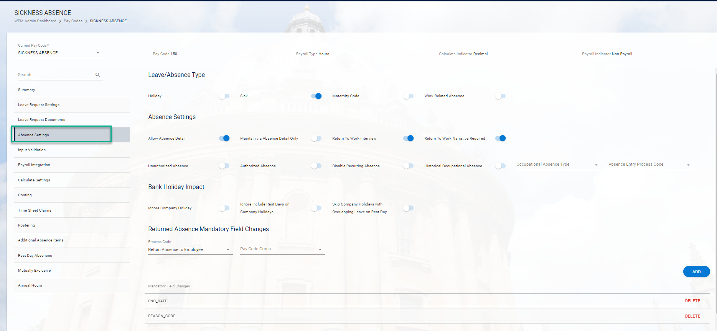
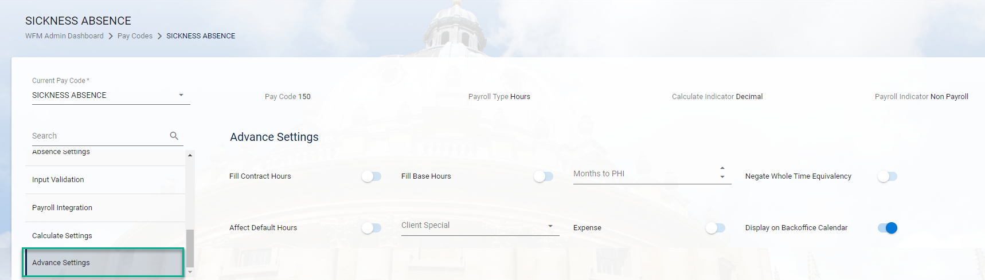
Public Holiday

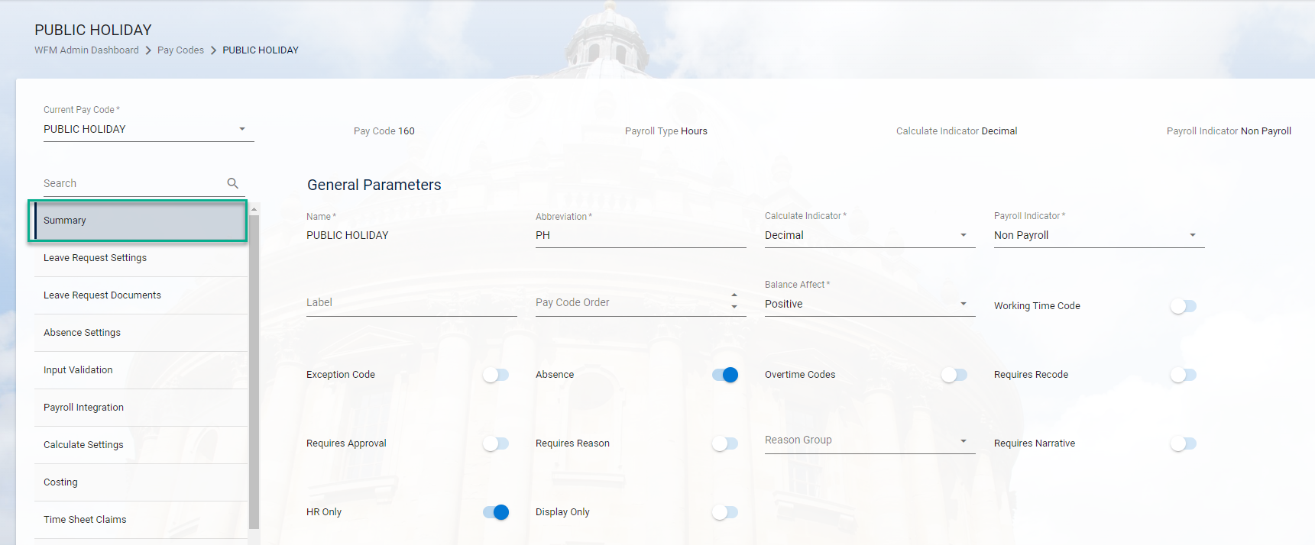
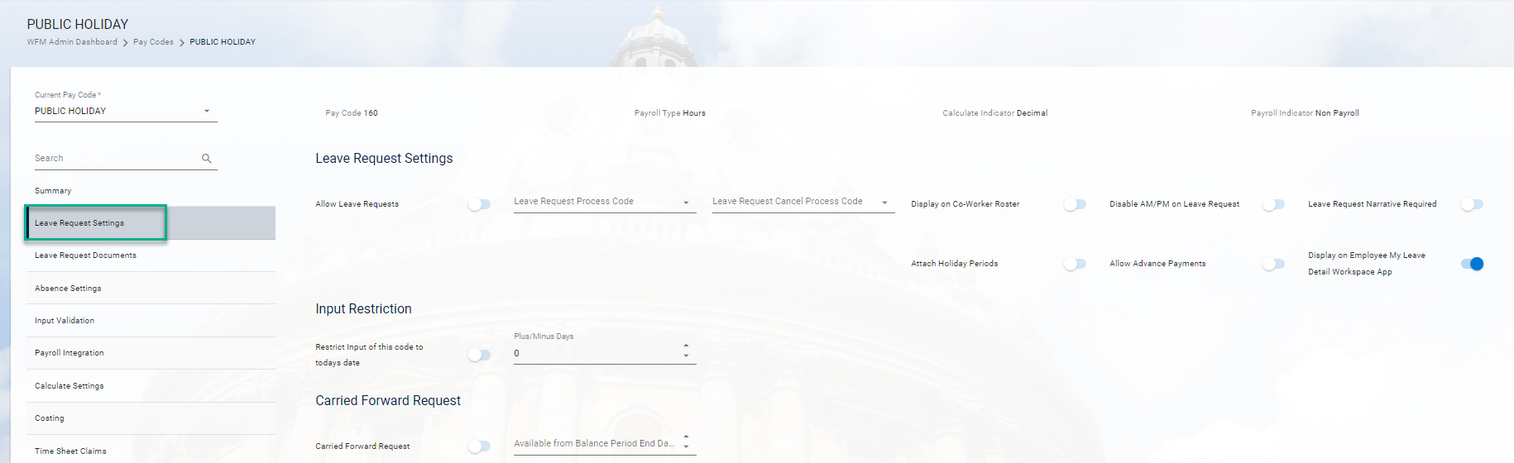
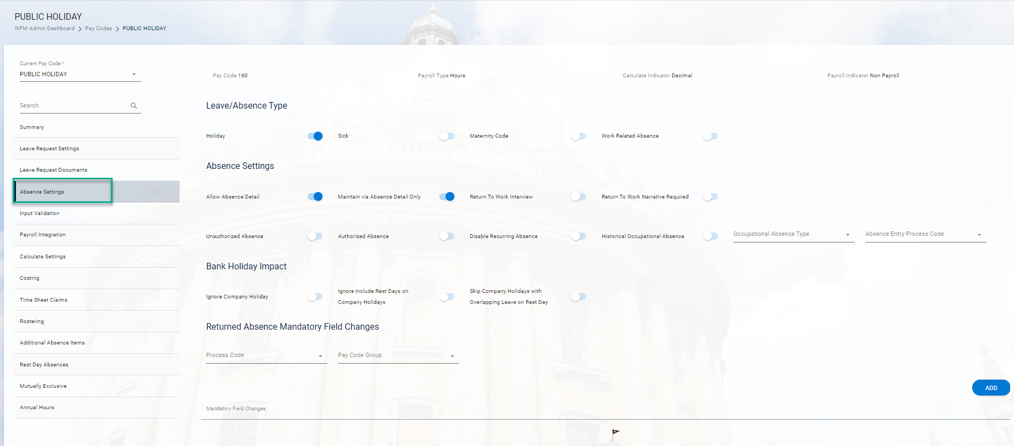

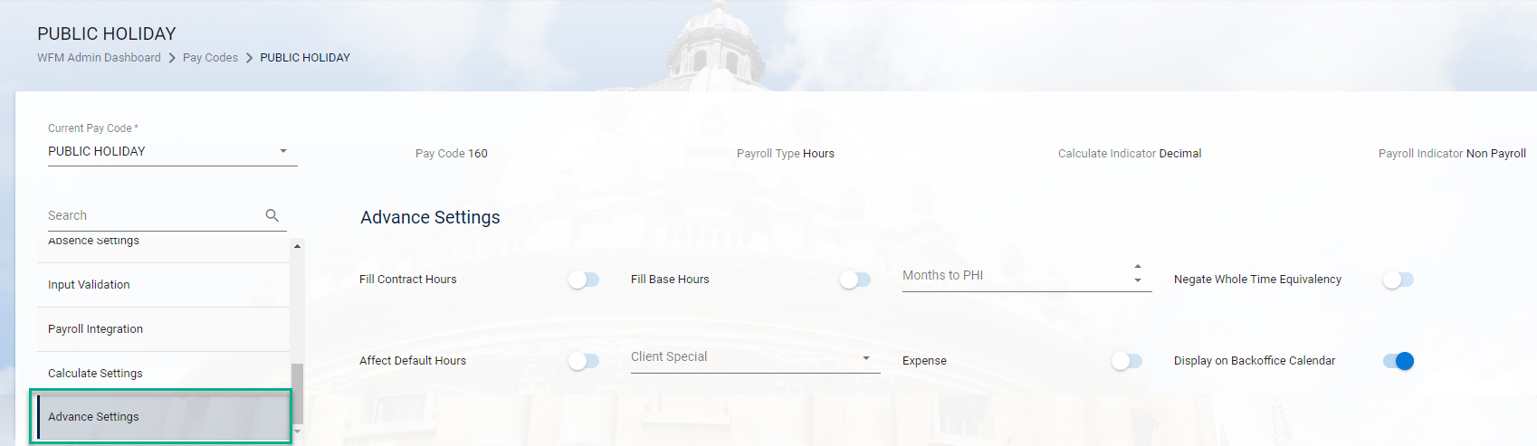

Fixed closure day

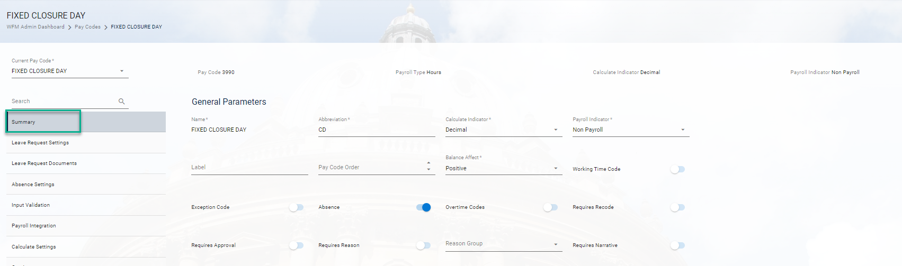
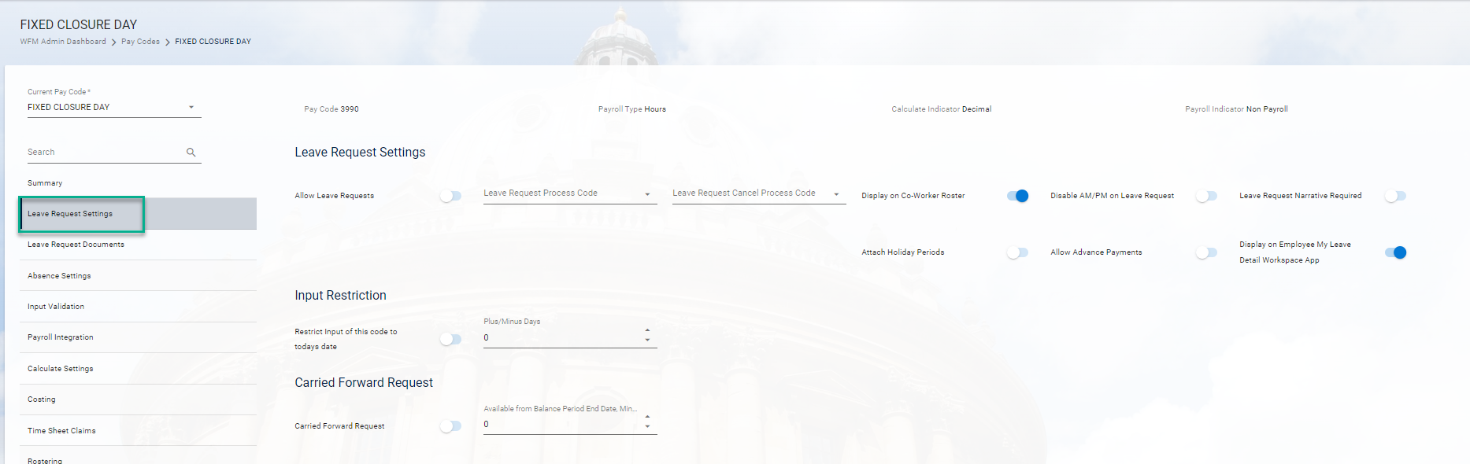

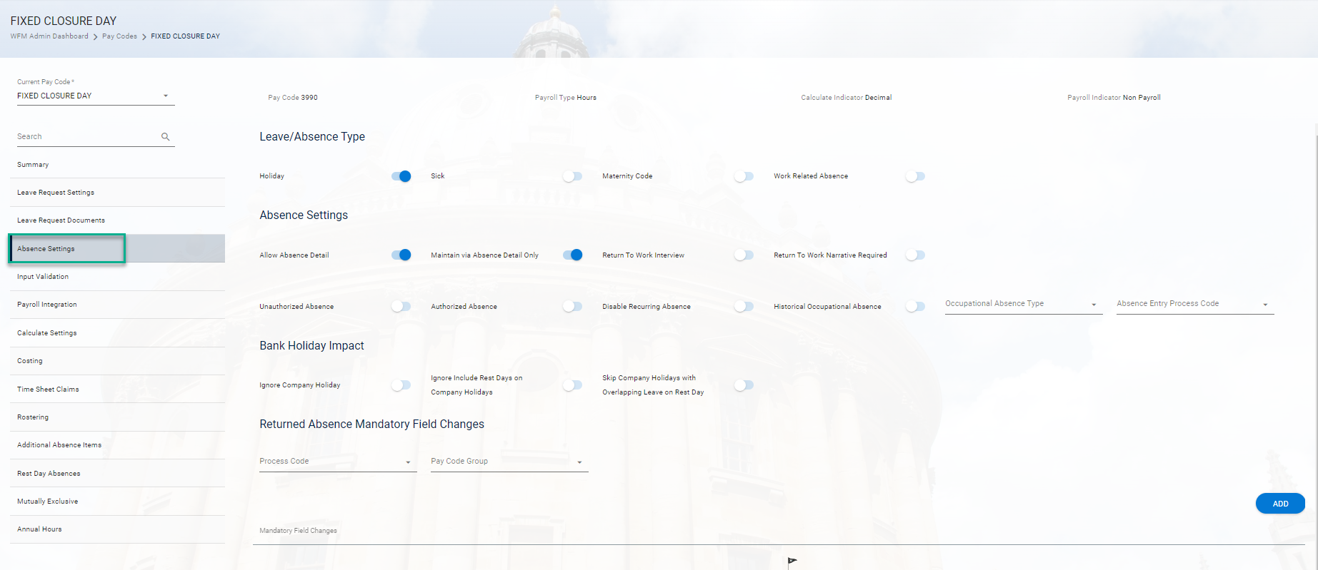

Annual leave
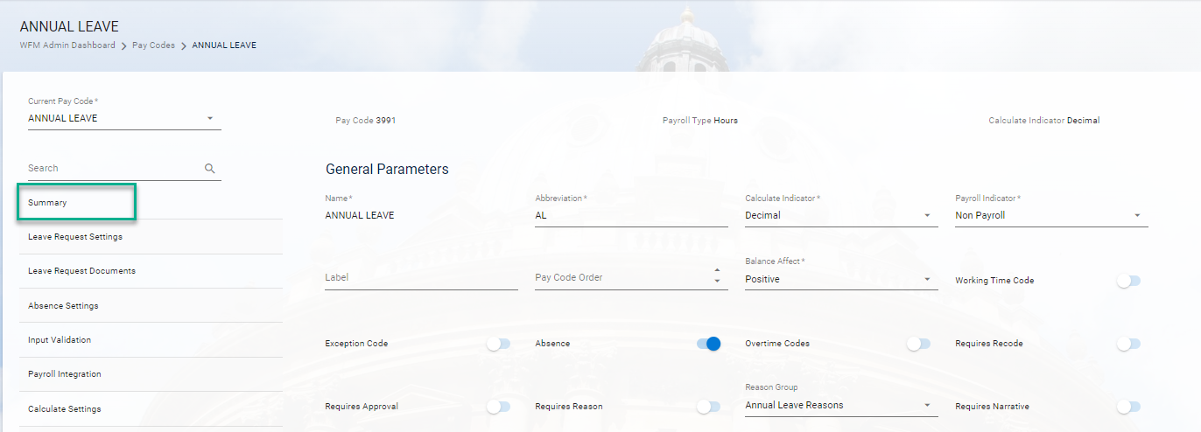

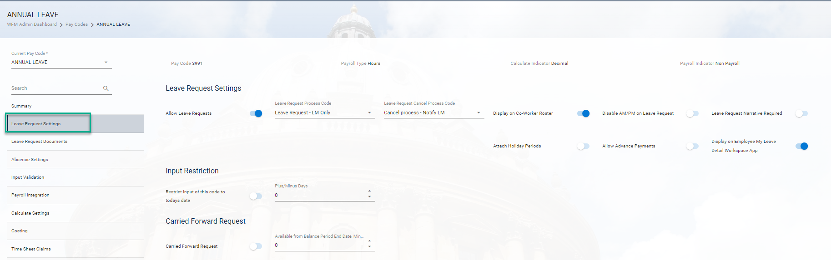
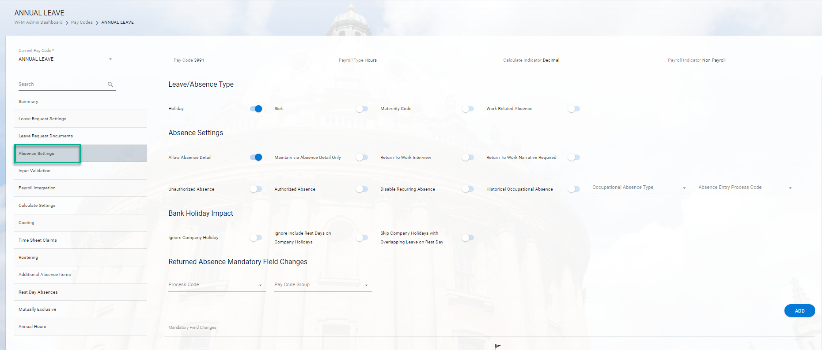

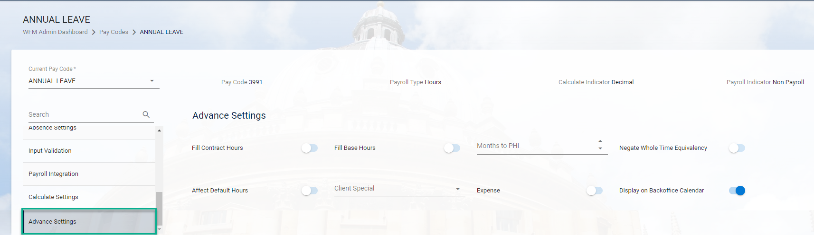

In the current University configuration, leave & absence codes do not deduct pay from workers, but many organisations would use them in this way, which explains why pay codes drive this part of the functionality.
Or deduction for earlier payment, where negative values are used
Not part of the current configuration, but included for reference

